Lab Manual
Practical and Skills Development

CERTIFICATE

THE ASSIGNMENT ENTERED IN THIS REPORT HAVE BEEN SATISFACTORILY PERFORMED BY

Registration No | :25BHI27125
Name of Student | :AYUSH SAXENA
Course Name | : Introduction to Problem Solving and Programming
Course Code | : CSE2721
School Name | : School of Computing Science
Engineering and Artificial Intelligence (SCAI)
Slot : B09+B12+B13
Class ID : BL2025260270796
Semester : FALL 2025/26

Course Faculty Name : Dr. Hemraj S. Lamkuche

Signature:

Practical Index
S. No. | Title of Practical | Date of Submission | Signature of Faculty
1 |  | /09/20225
2 | are_amicable(a, b) Function | 27/09/20225
3 | multiplicative_persistence(n) function | 27/09/20225
4 | is_highly_composite(n) Function | 27/09/20225
5 | mod_exp(base, exponent,modulus) function | 27/09/20225

Practical No: 1
Date: 27/09/2025

TITLE: Write a function called euler_phi(n) that calculates Euler's Totient Function, φ(n). This function counts the number of integers up to n that are coprime with n (i.e., numbers k for which gcd(n,k)=1). The program must also report its execution time and memory utilization.

AIM/OBJECTIVE(s): Euler's Totient Function (euler_phi)

METHODOLOGY & TOOL USED:

Python programming language

BRIEF DESCRIPTION:
This Python program calculates the sum of proper divisors of a given number. It takes an integer input n, iterates through all numbers from 1 to n-1, and adds those that evenly divide n. Finally, it prints the total sum of these divisors as the result.

RESULTS ACHIEVED:
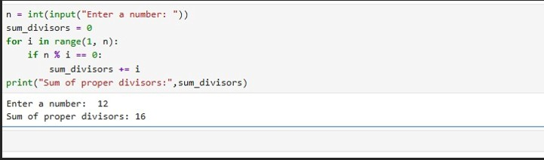

SKILLS ACHIEVED:
Iteration and conditional accumulation.
Understanding of divisors and proper divisors.

Practical No: 2
Date: 27/09/2025

TITLE: are_amicable(a, b) Function

AIM/OBJECTIVE(s):Write a function are_amicable(a, b) that checks if two numbers are amicable (sum of proper divisors of a equal’s b and vice versa).

METHODOLOGY & TOOL USED:Python programming language

BRIEF DESCRIPTION:

This Python program checks if two numbers are amicable. It defines a function aliquot_sum(n) that calculates the sum of proper divisors of
n. Then, it compares whether each number equals the other’s divisor sum. If true, it prints “Amicable numbers”; otherwise, it prints “Not amicable.”

Result:
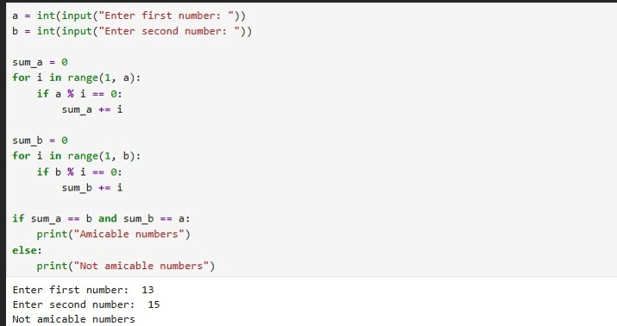

SKILLS ACHIEVED:
Function Reusability: Leveraging existing functions to build new solutions

Logical Condition Construction: Combining multiple conditions with AND logic

Practical No: 3
Date: 09/09/2025

TITLE:multiplicative_persistence(n) function

AIM/OBJECTIVE(s):Write a function multiplicative_persistence(n) that counts how many steps until a number's digits multiply to a single digit

METHODOLOGY & TOOL USED
Python programming language

BRIEF DESCRIPTION:
This Python program finds the multiplicative persistence of a number — the number of steps required to reduce it to a single digit by multiplying its digits repeatedly. It loops while the number has more than one digit, multiplies all digits together, updates the number, and
counts the steps
RESULTS ACHIEVED:
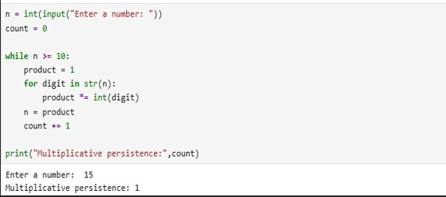
SKILLS ACHIEVED:
Type Conversion: converting between integers and strings for digit manipulation

Iterative Process Control: Managing loops until convergence criteria are met

Practical No: 4
Date: 27/09/2025

TITLE:is_highly_composite(n) Function

AIM/OBJECTIVE(s):Write a function is_highly_composite(n) that checks if a number has more divisors than any smaller number

METHODOLOGY & TOOL USED:
Python programming language

BRIEF DESCRIPTION:
This Python program checks whether a number is highly composite. It defines a function count_divisors(x) to count total divisors of any number. Then, it compares the divisor count of the input number with all smaller numbers. If any smaller number has equal or more divisors, it’s not highly composite.

Result:
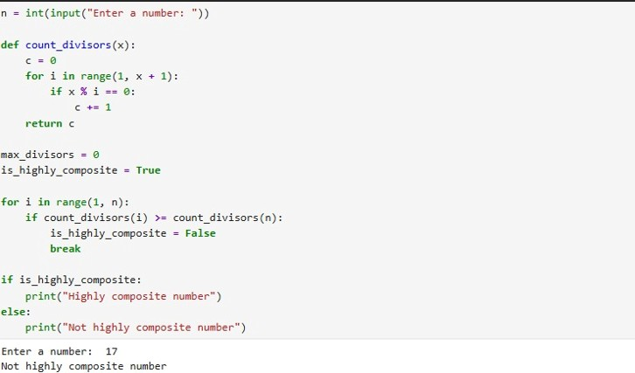
SKILLS ACHIEVED:
Algorithm Optimization: Using square root method for efficient divisor counting.

Comparative Analysis: Evaluating a number against all smaller numbers.

Practical No: 5
Date: 27/09/2025

TITLE:mod_exp(base, exponent,modulus) function

AIM/OBJECTIVE(s):Write a function for Modular Exponentiation mod_exp(base, exponent, modulus) that efficiently calculates (base^exponent) % modulus.

METHODOLOGY & TOOL USED:Python programming language

BRIEF DESCRIPTION:
This Python program performs modular exponentiation. It takes base, exponent, and modulus as inputs, then repeatedly multiplies the base and applies the modulus in each iteration. This keeps intermediate results small and prevents overflow. Finally, it prints (base^exponent) % modulus, a key operation in cryptography and modular arithmetic..
RESULT:
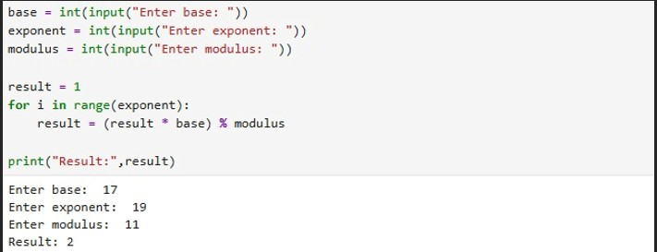

SKILLS ACHIEVED:

Binary Exponentiation: Implementing efficient power computation using bit manipulation.

Modular Arithmetic: Applying mathematical properties to handle large numbers efficiently.

